AGPTek Bluetooth MP3 Player Quick Guide

AGPTek Bluetooth MP3 Player at a glance: 1

Bluetooth pairing: 1

How to convert/split APE music 2

Can’t read E-book on the MP3 Player? 3

AGPTek Bluetooth MP3 Player at a glance:

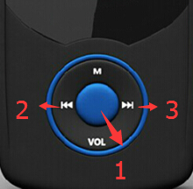

**M:**  Press to set the Play Mode

**1:** Play/Pause:

Press shortly, your player will play or pause

Press and hold for three seconds, your player will turn off

**2：** Left/Previous/Rewind: (press and hold for rewind)

**3：** Right/Forward :Press for next track

Press and hold for Fast Forward

**Vol:** Press shortly to return to the main menu

Press and hold until the volume menu appears, then Press **2** and **3** button to adjust the volume level.

Bluetooth pairing:

1. Place the Bluetooth device to be paired nearby the device.
2. Select Bluetooth (Press right or left to switch).

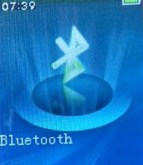

1. Turn on the device’s Bluetooth you want to connect with.
2. Select “Bluetooth Search”, when your device’s name shows up , select it.
3. When paring is completed, the player will indicate “Bluetooth connected”

Note: when the player is in Bluetooth mode, you cannot change the Play Mode unless you disable the Bluetooth.

How to load APE (lossless) music

An entire multi-track audio CD may be ripped to a single audio file and a cue sheet. However software audio players and hardware digital audio players often treat each audio file as a single playlist entry, which can make it difficult to select and identify the individual tracks. A common solution is to split the original audio file into a series of separate files, one per track.

Step 1

Download TTplayer via <http://images.agptek.us/image/TTPlayer.rar> .Unzip TTplayer. And then add your APE music into TT player.

Step 2

Select the music you need to convert, and then right click, choose “Convert Format”, as the picture shows:



Step 3

Now Choose “Monkey’s Audio(APE)编码器”-----“Convert now”



Step 4

When the conversion is finished, put the split APE music into your MP3 player. Now, enjoy your music!

**Precautions:**

1. Do not drop the player or put any heavy object on top of it.
2. Do not modify, repair, or disassemble.
3. Do not expose directly to water, alcohol, benzene, etc.
4. Do not use while driving, cycling, or operating any motorized vehicle.
5. Do not leave the device under direct sunlight or high temperature.
6. If the player causes interference to radio or TV reception, turn the player off and move it away from the radio or TV.
7. Avoid using the player at high volume.

**Can’t read E-book on the MP3 Player?**

Open your txt document, click “save as”, as the picture shows:

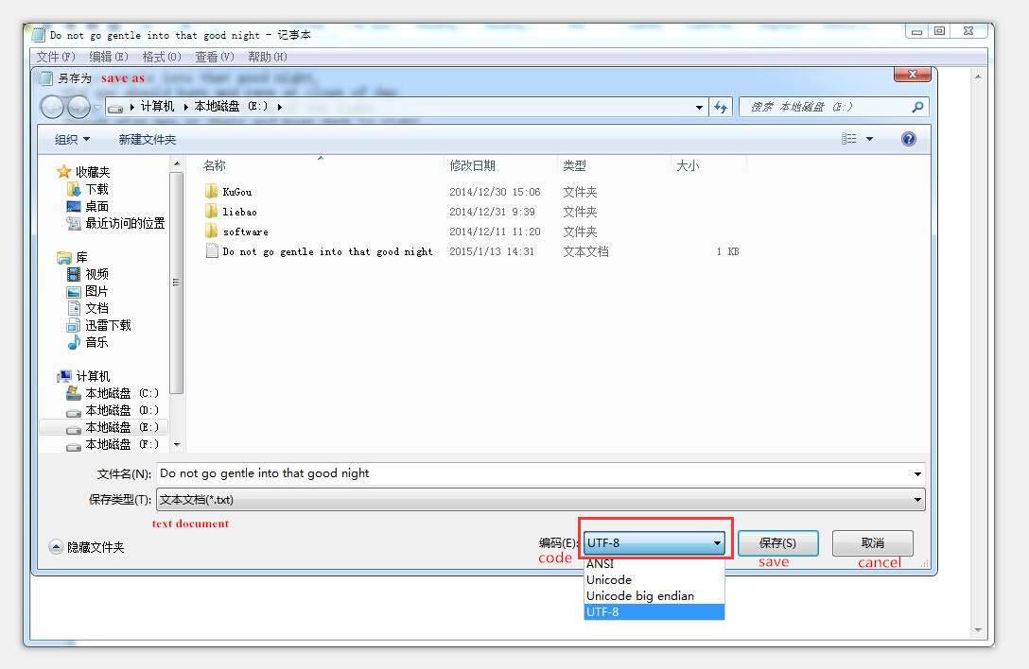Select the code(编码in Chinese) as “UTF-8” and then save.

Copy the txt file to E-Book folder in the MP3 Player.

Now you can read the E-book!